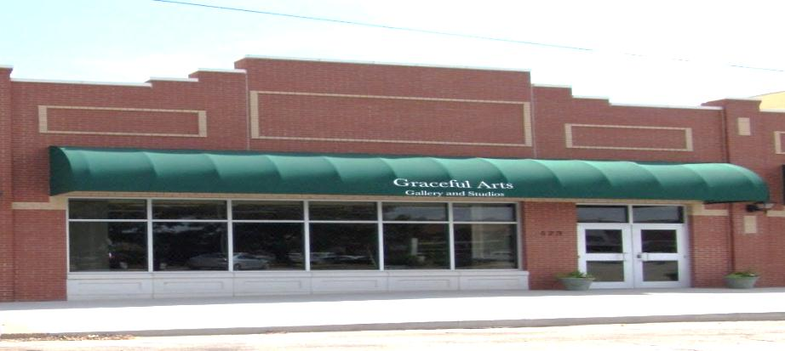
Graceful Arts Center

Spring Class Schedule 2023
Classes/Time Start Date Tuition
Tuesday Beginners Draw to Paint (8-14yr - 3:30-5:30) Jan 10th - Jan 31st $40/monthly
**Some supplies required** Feb 7th - Feb 28th March 7th,21st, 28th
April 4th, 11th,18th, 25th

Wednesday Basics in Arts (K-10yr - 3:30-5:00) January 11,18,25
**Pre-enroll or Drop-in** February 1,8,15,22 $15/weekly
March 1,8,22,29
April 5,12,19,26
May 3,10

Friday - Children’s Make-n-Take Craft (ages K-12yr)
Winter Craft (3:30-5:30pm) January 13 $20
Valentine Craft (3:30-5:30pm) February 10 $20
Easter Craft (3:30-5:30pm) April 14 $20
Mother’s Day Craft (3:30-5:30pm) May 12 $20

Private Paint Parties – Call for more information

Classes &Workshops (Youth to Adult) – Pre-Enrollment Required
Artists Talks First Friday Art Walk Monthly Free to Public

Paint Parties for All Ages – Call to schedule

580-327-2787(ARTS)
523 Barnes Alva, OK 73717
gracefulartscenter@gmail.com
*Like us on Facebook*
NO CLASSES 3/10-3/20

